Ride Shield: Bike Theft Analysis
Ashana Chavan¹, Tejas Patil², Rohit Patil³, Aayush Pise⁴, Siddheshwar Patil⁵ , Pallavi Jadhav⁶

¹UG Scholar, Dept. of CSE, D. Y. Patil college of Engg. & Tech., Kolhapur, Maharashtra, India ²UG Scholar, Dept. of CSE, D. Y. Patil college of Engg. & Tech., Kolhapur, Maharashtra, India ³UG Scholar, Dept. of CSE, D. Y. Patil college of Engg. & Tech., Kolhapur, Maharashtra, India ⁴UG Scholar, Dept. of CSE, D. Y. Patil college of Engg. & Tech., Kolhapur, Maharashtra, India
⁵Head of Department, Dept. of CSE, D. Y. Patil college of Engg. & Tech., Kolhapur, Maharashtra, India

⁶Assistant Professor, Dept. of CSE, D. Y. Patil college of Engg. & Tech., Kolhapur, Maharashtra, India

Emails: ¹chavanashana@gmail.com, ² patiltejas1004@gmail.com, ³ rohit5003patil@gmail.com , ⁴aayushpise.15@gmail.com,

⁵siddheshwar.patil@gmail.com, ⁶pallavigholap@gmail.com

Abstract
Bike theft remains a recurring urban problem that causes significant financial loss and social inconvenience. Conventional crime monitoring approaches are largely reactive, relying on manual reporting and post-incident investigation, which limits timely preventive action. This paper presents Ride Shield, a spatial–temporal bike theft analysis and mapping system designed to transform historical crime data into actionable visual intelligence for smart city decision support. The proposed framework integrates a MongoDB database, Fast API backend, and a React–Tailwind interactive dashboard to process multi-year theft records. Robust data preprocessing techniques, including field normalization, geolocation validation, and temporal parsing, ensure reliable analytical inputs. Spatial aggregation and time-based profiling are performed to identify high-risk zones, peak theft hours, and frequently targeted vehicle categories. The system generates interactive geospatial heatmaps and trend visualizations that highlight theft density and recurring patterns across police jurisdictions. Experimental findings reveal consistent hotspot concentrations in high-traffic urban regions and peak activity during evening hours (18:00–22:00). By converting raw crime records into intuitive visual analytics, Ride Shield enhances situational awareness and supports data-driven patrol allocation and preventive planning. The framework establishes a scalable foundation for future integration of predictive modeling and real-time crime data streams within smart city infrastructures.
Keywords: Bike Theft Analysis, Spatial–Temporal Analytics, Crime Mapping, Geospatial Visualization, Heatmap Analysis, Smart City Surveillance, Urban Safety, Fast API, MongoDB, Interactive Dashboard.

INTRODUCTION

Bike theft has turned into a frequent and expensive dilemma in many urban regions, undermining personal mobility, public safety, and the public’s confidence in law enforcement. While factors such Bike theft has turned into a frequent and expensive dilemma in many urban regions, undermining personal mobility, public safety, and the public’s confidence in law enforcement. While factors such as increased surveillance and awareness may deter some bike thefts, the occurrence of reported thefts

continues to rise, partly due to inadequate incident tracking and the absence of proactive preventive planning. Traditional crime monitoring systems authenticate theft data mainly through reporting by victims or patrolling officers and correlate it with post-incident documentation, offering limited insight into recurring trends or the geographic concentration of theft hotspots.

With more crime data now available in digital form and better tools to display this information, we can study bike thefts more clearly. These tools help us understand how thefts change over time and which places are affected the most. Visualization plays a crucial role here, as raw numerical crime data alone cannot reveal hidden trends, high risk zones, seasonal variations, or the shifting intensity of theft activity. Geospatial heatmaps, time-series graphs, and filter-based visual dashboards transform complex datasets into intuitive visual patterns, making it easier for authorities to identify where and when thefts cluster most intensely. These visual representations not only improve the clarity of crime distribution but also support evidence-based decision-making.

The project aims to create a comprehensive Bike Theft Mapping System that compiles and analyzes historical theft data to identify recurring spatial and temporal patterns. The system generates interactive heatmaps, trend graphs, and police-station-wise filtered views to showcase theft density and time-dependent fluctuations. By converting data into clear visual formats, the system enhances situational awareness, helps law

enforcement allocate patrols more effectively, and enables targeted interventions, ultimately contributing to a proactive strategy for reducing bike theft incidents.

REVIEW OF LITERATURE
Existing research on crime mapping and hotspot analysis has established geospatial and temporal techniques as effective tools for revealing where and when offences concentrate. Patil and Jadhav [1] applied pattern analysis to large-scale police records, demonstrating that aggregating incidents by administrative units uncovers repeat-offence clusters and supports prioritization of patrol resources. Their work highlights the value of organizing historical records into spatial groups to make hotspot patterns actionable for law enforcement.
Studies that explicitly combine GIS with statistical clus- tering show how visual mapping directly informs operational decisions. Kumar and Saini [7] used GIS-based mapping and clustering to identify crime hotspots across Haryana, reporting that map-driven presentations helped local authorities reassign beats and schedule patrols more efficiently. Their emphasis on geocoding accuracy, grid/ward aggregation, and clear map legends is particularly relevant for any focused theft-mapping effort.
Temporal analysis complements spatial mapping by revealing periodicity and peak windows for theft incidents. Roy and Bhattacharya [8] examined seasonal and time-of-day variations in burglary and demonstrated that temporal profiling improves the interpretability of hotspot maps. Incorporating temporal aggregation (hourly, daily, seasonal) into mapping workflows enables stakeholders to detect not only persistent hotspots but also transient spikes that warrant targeted operations.
Application-oriented system studies illustrate how mapping and dashboards translate analysis into practice. Joshi and Mehta [11] described an IoT-enabled city-level crime mapping prototype that integrated incident feeds into a visualization dashboard for municipal use. Their work underscores practical considerations such as real-time data ingestion (where available), user-friendly filter controls, and responsive layouts suitable for both desktop and mobile users — all important design lessons for a bike-theft mapping tool.
Despite these advances, most prior work addresses crime at a broad category level (property crime, burglary, general hotspots) rather than concentrating exclusively on bike theft. Bike theft has distinct spatial patterns (parking lots, transit nodes, educational institutions) and temporal features (com mute hours, weekends) that merit a dedicated study. Moreover, while many projects outline mapping frameworks and dash boards, fewer present a focused pipeline combining careful geocoding, grid-based aggregation, and time-windowed visualizations specifically tuned for bicycle and motorcycle thefts.
This research addresses those gaps by concentrating solely on bike theft: compiling location-tagged theft records, applying robust geospatial aggregation and time-based profiling, and producing interactive heatmaps and trend charts tailored to typical bike-theft scenarios. The resulting system is designed to provide clear, operationally useful maps and temporal summaries that help authorities prioritize patrols and design targeted preventive measures.

METHODOLOGY

The proposed Ride Shield: Bike Theft Analyzer follows a structured data pipeline integrating MongoDB, Fast API, and React/Tailwind for analyzing and visualizing bike theft pat terns across Kolhapur. The workflow includes data collection, preprocessing, aggregation, visualization, and evaluation.

System Overview
The system adopts a three-tier architecture:
- Database: MongoDB stores multi-year theft records with fields such as POLICE STATION, PLACE, MAKE, DATE, TIME OF DAY, and geo coordinates.
- Backend: Fast API provides REST APIs for filtering, aggregation, heatmap generation, and report creation.
- Frontend: React with Tailwind CSS renders interactive dashboards, filters, charts, and Folium/Leaflet based maps.

Data Preprocessing
Raw data from the MongoDB collection (thefts collection) contained inconsistent naming, missing values, and irregular coordinates. Data cleaning steps include:
- Field normalization to handle variations (e.g., Make/MAKE).
- Robust date parsing using multiple formats.
- Validation and filtering of latitude/longitude ranges.
- Uppercasing and trimming of categorical fields.
- Filling missing entries with "Unknown” and removing invalid records.
This ensures reliable and standardized input for analysis.

Data Aggregation and Analysis

Aggregation is performed through MongoDB pipelines and pandas operations:

Spatial: Grouped by police station, place, or grid to detect hotspots.

Temporal: Analyzed by time-of-day, day-of-week, and month to reveal trends.

Statistical: Summaries of top police stations, models, and peak theft periods.

Visualization and Dashboard

The dashboard provides an interactive interface to explore theft patterns:

Heatmaps showing theft density using Folium/Leaflet.

Bar and line charts displaying theft counts and time trends.

Filter controls for date, location, vehicle make, and category.

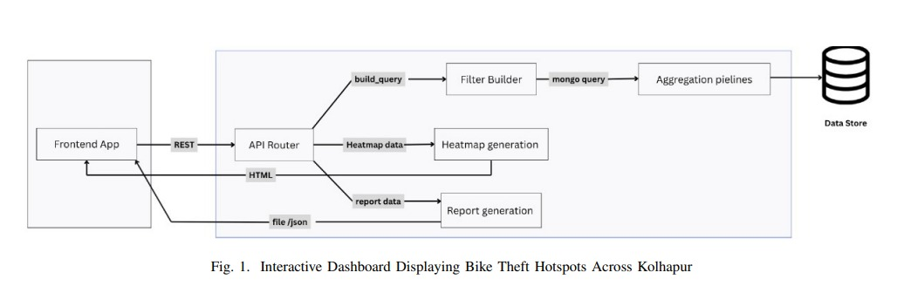

Reporting and Evaluation

The backend generates JSON-based analytical reports using pandas, and the validation process included several important checks to ensure accuracy.

Geolocation information was checked for correctness, and duplicate records were identified and removed. •

Aggregated outputs were compared directly with the raw dataset totals to verify consistency.

API performance was tested with large query requests to measure responsiveness under heavier loads.

The methodology emphasizes reproducible data cleaning, structured aggregation, and clear spatial-temporal visualization to support proactive analysis of bike theft incidents.

RESULT AND DISCUSSION

The developed Ride Shield dashboard enables dynamic visualization and analysis of bike theft incidents in Kolhapur. The system integrates multiple data views, allowing users to filter and examine theft trends spatially and temporally.

- System Output and Visualization :
The interactive dashboard presents theft information through three key visual components:
- Heatmap Visualization: Folium-based heatmaps display theft density across the city, highlighting high-risk regions such as major parking zones and transit hubs.
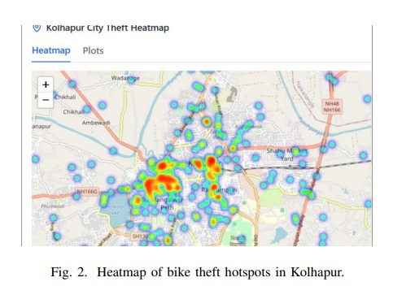

- Temporal Trends: Line charts show daily and hourly fluctuations, identifying evening and weekend peaks in theft activity.

- Statistical Summaries: Bar charts summarize top police stations, most stolen vehicle models, and the busiest time slots, aiding comparative analysis.

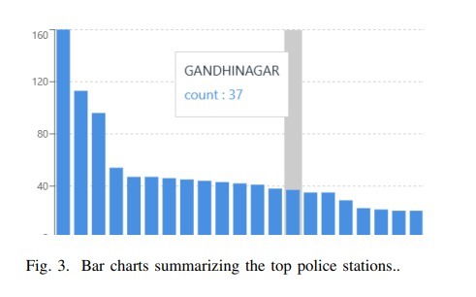
- Analytical Findings
Analysis of the aggregated dataset revealed clear and recur ring spatial–temporal trends:
- Theft incidents were predominantly concentrated in central and high-traffic zones of the city.
- Temporal analysis indicated notable peaks during late evening hours (18:00–22:00) and on weekends.
- Several police station jurisdictions showed repeated theft clusters, suggesting persistent hotspot locations.
- Hero motorcycles emerged as the most frequently stolen category, likely due to their higher prevalence in daily use.
These patterns provide valuable operational insights, enabling more informed patrol planning and targeted awareness initiatives in high-risk areas.

- System Performance and Usability
Backend tests demonstrated efficient API responses under filtering operations, with average query times under one second for moderate datasets. MongoDB aggregation pipelines provided scalability for larger record sets. User evaluation confirmed that the dashboard’s visual components and filters offer an

intuitive interface for non-technical users, facilitating data-driven decision-making by police authorities and administrative staff.

- Discussion
The results validate the effectiveness of spatial-temporal mapping for localized crime analytics. Visualizations simplified interpretation compared to static tabular reports and enhanced situational awareness. While the system successfully identifies theft hotspots and peak periods, limitations persist in the completeness of incident reporting and precision of geolocation data. Future iterations will focus on integrating automated data validation and predictive modeling to extend analytical capability. Overall, the results demonstrate that Ride Shield delivers actionable insights through a robust, interactive dashboard that supports proactive crime monitoring and strategic intervention planning.

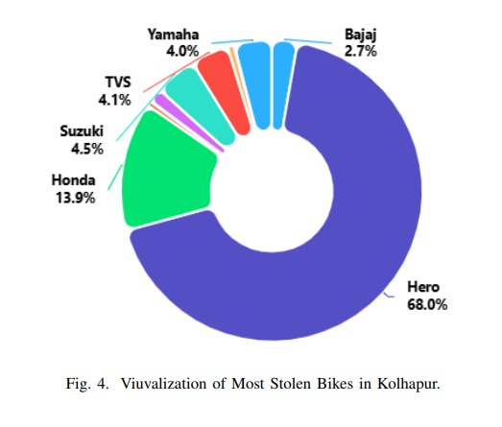

CONCLUSION
The Ride Shield: Bike Theft Analyzer provides an effective framework for visualizing and interpreting bike theft incidents across Kolhapur. By integrating a Fast API backend, MongoDB database, and a React–Tailwind frontend, the system enables real-time analysis through spatial and temporal aggregation. Interactive heatmaps and statistical dashboards allow stake holders to identify theft hotspots, peak periods,
and vulnerable vehicle categories with clarity and
accuracy. The approach demonstrated that combining structured data preprocessing with geospatial visualization significantly im proves situational awareness for law enforcement. The dash board’s responsiveness and ease of use make it a practical tool for operational decision-making and public safety planning. Future enhancements will focus on incorporating predictive modeling for theft trend forecasting, implementing geospatial indexing for faster queries, and expanding reporting capabilities to generate PDF or CSV summaries. Further integration with live police data streams could make the system an essential component of smart city surveillance infrastructure. Overall, Ride Shield establishes a scalable and adaptable foundation for data-driven crime analysis and prevention.

- ACKNOWLEDGEMENTS
For the development of our project named “Ride Shield: Bike Theft Analyzer” our guide and our AIML Department Head Dr. S. V. Patil helped us navigate through our entire path of project and provided guidance we needed from time to time. We would also like to thank SP Office (Kolhapur) for recognizing our project.

- REFERENCES

[1]. Patil, R. and Jadhav, S. (2016). Crime pattern analysis using clustering on NCRB data. International Journal of Computer Applications.
[2]. Gupta, A., Verma, R., and Sharma, P. (2017). A regression-based analysis of crime trends in Delhi. Indian Journal of Data Science.
[3]. Singh, V. and Chandra, S. (2018). Crime prediction using decision tree and random forest algorithms: A study in Uttar Pradesh. IEEE International Conference on Data Science.
[4]. Sharma, K., Kumar, P., and Nair, R. (2019). Classification of crimes using support vector machines: A case study of Bangalore. International Journal of Machine Learning Research.
[5]. Patel, D., Rana, H., and Trivedi, M. (2020). Crime prediction using logistic regression and KNN: A Gujarat case study. International Journal of Emerging Technologies.
[6]. Kumar, A. and Kaushik, R. (2022). Gradient boosting approach for property crime prediction in northern India. International Journal of Data Analytics.
[7]. Kumar, D. and Saini, A. (2020). GIS-based mapping and clustering analysis of crime hotspots in Haryana. Journal of Spatial Information Science.
[8]. Roy, S. and Bhattacharya, M. (2021). Spatial-temporal analysis of burglary trends in Kolkata using predictive modeling. Indian Journal of Criminology.
[9]. Rani, S. and Bansal, M. (2020). Predicting cybercrime incidents in India using Naive Bayes classifier. International Journal of Information Security.
[10]. Mishra, V., Singh, P., and Tiwari, A. (2021). Deep learning framework for phishing detection in Indian banking systems. IEEE Access.
[11]. Joshi, A. and Mehta, V. (2021). IoT-enabled crime prediction and alert system for smart cities: A case study of Pune. Smart City Technologies Journal.
[12]. Singh, R., Chauhan, P., and Kaur, J. (2022). Mobile-based citizen alert system integrated with predictive crime models. International Journal of Smart City Innovation.

